Designed by: Hira Farman**CLASS ACTIVITY WEEK 2 FACULTY OF ENGINEERING, SCIENCES AND TECHNOLOGY**

**Subject: Artificial Intelligence Instructor: Hira Farman ,Safdar Hussain**

**S.No**

**. Assignment Coverage**

**Q#1** Write a python program to take marks as input from student and print their corresponding grades. Criteria is given below.

90 and above A

80 to 89 B

60 to 79 C

33 – 59 F

Expected output:

**Input:** marks : 85

Congratulations!you got B grad ..

**Source Code:**

marks=int(input("Enter Marks: "))  
if marks>=90:  
 print("Congratulations!you got A grad .. ")  
elif marks>=80 and marks<=89:  
 print("Congratulations!you got B grad .. ")  
elif marks>=60 and marks<=79:  
 print("Congratulations!you got c grad .. ")  
elif marks>=33 and marks<=59:  
 print(" Fail ")

**Output:**

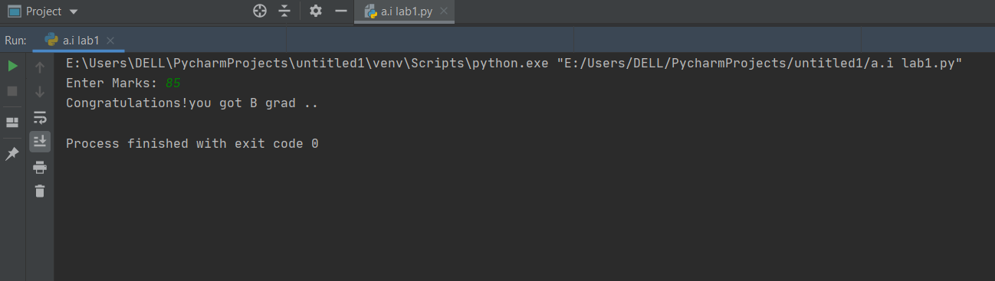

**Q#2** Write a Python program to convert temperatures to and

from celsius, Fahrenheit.

Formula : c/5 = f-32/9

*Expected Output* :

Enter temp in Celsius: 60°C

Temperature in Fahrenheit is :140

Source Code:

Celsius = int(input("Enter a temperature in Celsius: "))  
  
Fahrenheit = 9.0/5.0 * Celsius + 32

print ("temperature in farenheit:",Fahrenheit)

**Output:**

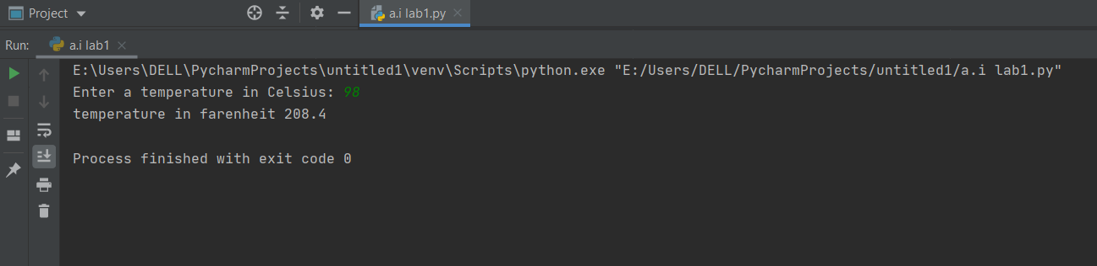

**Q#3** Write a Python program to count the number of even and

odd numbers from a series of numbers.

Let’s numbers be: 2, 4, 5, 7, 8, 9,11, 14,15,17

**Source Code:**

numbers = (2, 4, 5, 7, 8, 9, 11, 14, 15, 17)  
count_odd = 0  
count_even = 0  
for x in numbers:  
 if not x % 2:  
 count_even+=1  
 else:  
 count_odd+=1  
print("Number of even numbers :",count_even)  
print("Number of odd numbers :",count_odd)

***Output* :**

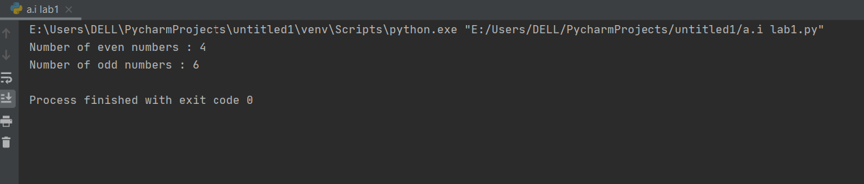

Q#4 Generate the given pattern using nesting of loop concept in python.

**Source Code:**

row = int(input('Enter number of rows required: '))  
  
for i in range(row, 0, -1):  
 for j in range(row - i):  
 print(' ', end='')   
  
 for j in range(2 * i - 1):  
 print(j, end='')   
 print()

**Output:**

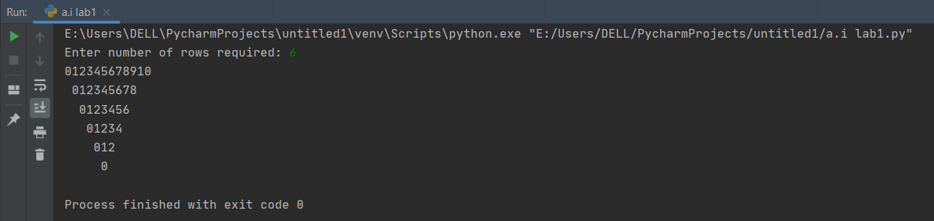

**Q#5** Write a Python program to generate 26 text files named

A.txt, B.txt, and so on up to Z.txt.

**Source Code:**

import string, os  
if not os.path.exists("letters"):  
 os.makedirs("letters")  
for letter in string.ascii_uppercase:  
 with open(letter + ".txt", "w") as f:  
 f.writelines(letter)

**Output:**

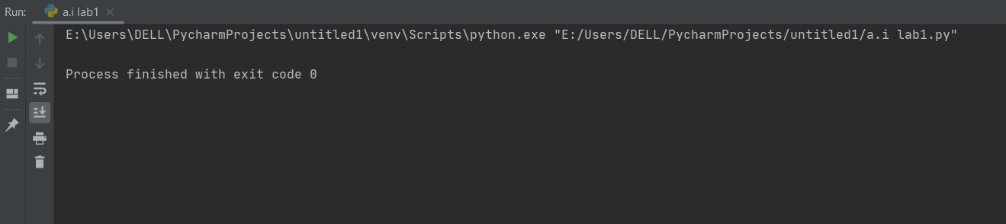

Designed by: Hira Farman